Library management system

Test Case: Confirm loans

TC03

**Version History**

|  |  |  |  |
| --- | --- | --- | --- |
| **Version** | **Date** | **Description** | **Author** |
| 1.0 | 1/10/2016 | Initial version | KAMAL RAJ KANDEL |

|  |  |
| --- | --- |
| **Test Case ID** | **TC03** |
| **Test Case Name** | Confirm loans |
| **Description** | This test case tests the process that the user must confirm the loan request of the books in order to borrow. It tests the following possible scenarios:   * Test if the system save member’s loan data when confirmed(TS01_01). * Test if the system escape from confirming page when member click “Cancel” button(TS02_02). * Test if display current loan list on confirm loan page when clicked on completed button(TS03_03). |
| **Pre-Conditions** | User should not have fine exceeding $10, shouldn’t have overdue loans and should not have taken more than 5 books, should not have enter the book that is unavailable. |
| **Post-Conditions** | System print the receipt with the borrower name, book name, borrowing date and due date to return. |

|  |  |
| --- | --- |
| **Data Required** | |
|  |  |
|  |  |

# Test script

**Version History**

|  |  |  |  |
| --- | --- | --- | --- |
| **Version** | **Date** | **Description** | **Author** |
| 1.0 | 1/10/2016 | Initial version | KAMAL RAJ KANDEL |

## The following test script were evaluated to test the Card Reader test case.

## 

|  |  |
| --- | --- |
| **Test ID:** | **TS01_01** |
| **Test Name:** | Test if the system save member’s loan data when confirmed |
| **Use Case Tested:** | Borrow books |
| **Test Description:** | Test how the system responds when the user confirms the loan. |
| **Pre-conditions:** | The user must have the library member card, should not have fine exceeding $10, should not have overdue loans and shouldn’t have taken more than 5 books and should not have enter the book that is unavailable. |
| **Post-conditions:** | System print the receipt of loan description. |
| **Notes:** | The user must confirm in order to print out the receipt. |
| **Result**  **(Pass/ Fail/ Warning/ Incomplete)** |  |

|  |  |  |  |  |
| --- | --- | --- | --- | --- |
| **Step Number** | **Test Step** | **Expected Test Results** | **Pass** | **Fail** |
| **1.** | User click on borrow books. | System display the card reader forum. |  |  |
| **2.** | User swipes the card | System display the user loan history and activate the barcode scanner. |  |  |
| **3.** | User scan the barcode of the book. | System display the book details along with the due date to return. |  |  |
| **4.** | User click the complete button. | System display the current loan list. |  |  |
| **5.** | User click the confirm button. | System print out the receipt. |  |  |

# 

# Result On The Screen

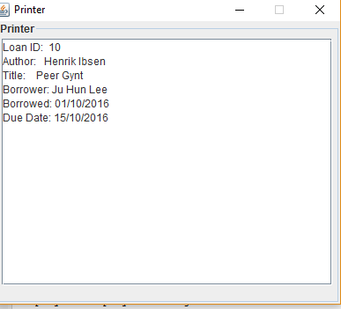

|  |  |
| --- | --- |
| **Test ID:** | **TS02_02** |
| **Test Name:** | Test if the system escape from confirming page when member click “Cancel” button |
| **Use Case Tested:** | Borrow books. |
| **Test Description:** | Test how the system responds when the user clicks the cancel button instead of pressing complete. |
| **Pre-conditions:** | The user must have the library member card, should not have fine exceeding $10, should not have overdue loans and shouldn’t have taken more than 5 books and should not have enter the book that is unavailable. |
| **Post-conditions:** | System will redirect to the starting page. |
| **Notes:** | The user should not press cancel if they want to get loan. |
| **Result**  **(Pass/ Fail/ Warning/ Incomplete)** |  |

|  |  |  |  |  |
| --- | --- | --- | --- | --- |
| **Step Number** | **Test Step** | **Expected Test Results** | **Pass** | **Fail** |
| **1.** | User click on borrow books. | System display the card reader forum. |  |  |
| **2.** | User swipes the card | System display the user loan history and activate the barcode scanner. |  |  |
| **3.** | User scan the barcode of the book. | System display the book details along with the due date to return. |  |  |
| **4.** | User click cancel button. | System redirect to starting page. |  |  |

# Result on the Screen

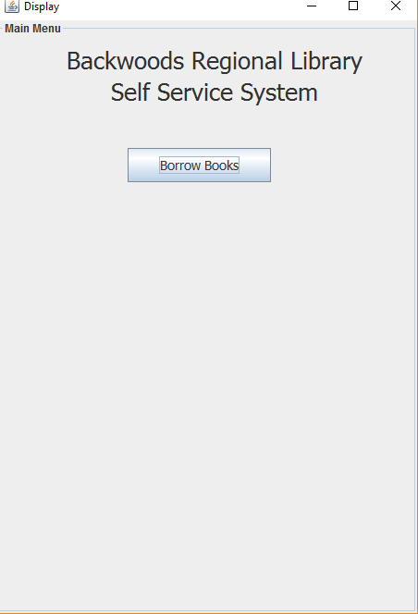

|  |  |
| --- | --- |
| **Test ID:** | **TS03_03** |
| **Test Name:** | Test if display current loan list on confirm loan page when clicked on completed button |
| **Use Case Tested:** | Borrow books. |
| **Test Description:** | Test how the system responds when the user click the complete button. |
| **Pre-conditions:** | The user must have the library member card, should not have fine exceeding $10, should not have overdue loans and shouldn’t have taken more than 5 books and should not have enter the book that is unavailable. |
| **Post-conditions:** | System display the current loan list. |
| **Notes:** | User should press confirm in order to get the book. |
| **Result**  **(Pass/ Fail/ Warning/ Incomplete)** |  |

|  |  |  |  |  |
| --- | --- | --- | --- | --- |
| **Step Number** | **Test Step** | **Expected Test Results** | **Pass** | **Fail** |
| **1.** | User click on borrow books. | System display the card reader forum. |  |  |
| **2.** | User swipes the card | System display the user loan history and activate the barcode scanner. |  |  |
| **3.** | User scan the barcode of the book. | System display the book details along with the due date to return. |  |  |
| **4.** | User click complete button. | System display the current loan list forum. |  |  |

# 

## 

# Result on the Screen

